|  |
| --- |
| Circle Language Spec: Parameters |

## Return Values

### Concept

Other programming language used to have only *one* return value. The new computer language can have *any* amount of output values or output objects, and no single parameter is selected to be *the* return value. I guess the concept of one return value dates from when a command was meant to be like a mathematical formula. I do not think, that limiting the amount of return values of a command to one, has a place in a more modern programming language anymore, because we have to realize, that programming is not mathematics.

### In a Diagram

As discussed in the article *Return Values*, the new computer language does not limit the amount of output objects. Any object readable from the outside, may be an output object.

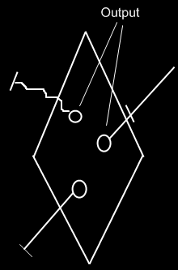

The correct usage of the term output will be discussed only later, in the *Advanced Command Topics*.